Gamma Rays Info Sheet

The third letter of the Greek alphabet is gamma (γ). Henri Becquerel is credited with discovering gamma radiation in 1896. Gamma rays are a highly penetrating ionizing electromagnetic radiation in the form of photons (light). They have the highest frequency and shortest wavelength in the electromagnetic spectrum.

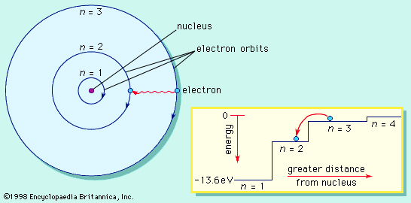
Electromagnetic radiation is released when electrons transition from higher energy levels to lower ones.
Most electromagnetic radiation (radio waves through x-rays, including visible light) is released when an electron transitions from a higher energy level to a lower one, such as indicated in the diagram. By conservation of energy, the energy of the released photon equals the change in energy of the electron.

Similarly, gamma rays are produced when the nucleus of an atom is in an excited state (called a metastable stateor an isomer) and then releases energy, becoming more stable. The reaction looks something like this: A* → A + γ, where A* represents the excited state of the nucleus. The resulting daughter nucleus, A, has the same atomic number as the parent nucleus, but a slightly smaller mass due to the release of energy.

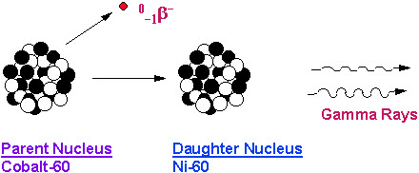
Gamma radiation.
Nuclei often reach excited states from another form of radioactive decay. For example, ⁶⁰Co decays by beta decay to an excited form of nickel, ⁶⁰Ni*. It then releases two gamma rays in succession as it decays to a more stable energy in the nucleus. The series of reactions is described by the following equations:
⁶⁰Co → ⁶⁰Ni* + e⁻ + $\overline{v}$ + 0.31 MeV (β⁻ decay)
⁶⁰Ni* → ⁶⁰Ni* + γ + 1.17 MeV
⁶⁰Ni* → ⁶⁰Ni + γ + 1.33 MeV

In the first equation, the energy describes the energy of the electron, while in the second and third, it describes the energy of the gamma rays.

Gamma rays can also be formed from subatomic particle interactions, such as electron-positron annihilation. When matter and anti-matter collide, they annihilate each other and release energy. In the case of electron-positron annihilation, this is in the form of two gamma rays equivalent in energy to the energy of the electron and positron.

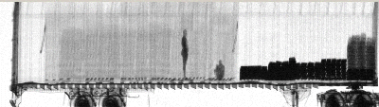
A gamma ray photograph of a transport truck showing two stowaways.

Gamma rays are the most penetrating of all of the forms of radiation. Gamma rays can be absorbed by denser materials (notice the blacker areas in the photo above), while passing through less dense materials. Gamma rays can interact with cells and DNA causing cell damage. While we all receive regular doses of gamma radiation from naturally occurring processes (such as radioactive decay), exposure to gamma radiation should be limited.

