How Electricity Generation Works Info Sheet
Generating Power
Most power plants, whether they are nuclear, hydroelectric, fossil-fueled or wind, do essentially the same job, transforming kinetic energy, the energy of motion, into a flow of electrons or what we call electricity.
At a power plant, a huge generator is used to make the electricity. Inside a generator, a giant magnet called a rotor spins inside coils of copper wire called a stator. This pulls the electrons away from their atoms, and a flow of electrons is created in the copper wires. This flow of electrons is what we know as electricity. Those electrons can then be sent along power lines to wherever electricity is needed.
Giant wheels called turbines are used to spin the magnets inside the generator. It takes a lot of energy to spin the turbine and different kinds of power plants get that energy from different sources. In a hydroelectric station, falling water is used to spin the turbine. In nuclear and fossil-fueled generating stations, steam is used. A wind turbine uses the force of moving air.
Understanding Power Demand
Unlike other commodities, electricity needs to be consumed as it is generated. There is currently no economical way to store large quantities of electricity for later use. The supply and demand for electricity must be kept in constant balance. As demand increases the supply must increase proportionately.
Electricity is usually measured in kilowatts and megawatts. One megawatt is equal to 1,000 kilowatts. One kilowatt could power 10 x 100-watt light bulbs or 50 x 20-watt compact fluorescent lights.
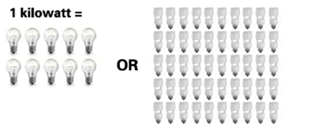
One kilowatt could power 10 x 100-watt light bulbs or 50 x 20-watt compact fluorescent lights.
To power the light bulbs for an hour you would need one kilowatt hour of electricity. A kilowatt hour is the amount of electricity consumed or generated over a one-hour period. An average house consumes 1,000 kilowatt hours of electricity each month.
Our society has a constant demand for electricity. Even when you are asleep, think of all the things in your home that continue using electricity like air conditioning, outdoor lighting, digital clocks, and all the gadgets that need to be recharged for the next day.

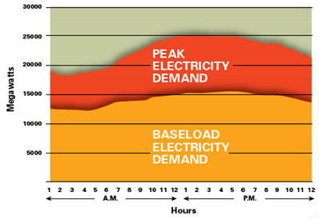
Electricity demand on a hot summer day.
Baseload vs. Peak Demand
The constant steady demand for electricity is called baseload demand. In Ontario the baseload demand for electricity is around 12,000-15,000 megawatts depending on the time of year. Ontario uses nuclear and large hydroelectric stations to meet baseload demand. This is because these types of generating stations can produce electricity at a constant and reliable rate.
However, the demand for electricity varies throughout the day. Between 4:00 and 7:00 p.m. as people arrive home from work and school and turn on their lights, ovens, televisions and dryers the demand for electricity is usually at its highest. This increase is what we call peak demand. Typically, peak demand in Ontario can be as much as 10,000 megawatts more than baseload demand. On the hottest days of the summer, this number can soar even higher as people turn up their air conditioners to keep cool.
To meet the sharp increases in electricity demand throughout the day Ontario uses fossil-fueled generating stations like coal, oil and natural gas plants as well as smaller hydroelectric stations. These types of generating stations can quickly increase or decrease their power output whereas a nuclear station is less able to vary its electricity output. As well, because electricity from fossil-fueled sources tends to be more expensive, and has a larger impact on the environment, it is best only to use them when demand exceeds the output of other generating sources.
Source:
Ontario’s clean power generator – Ontario Power Generation

